Lab 8

Building a Neural Network Model to Identify Diabetic Patients

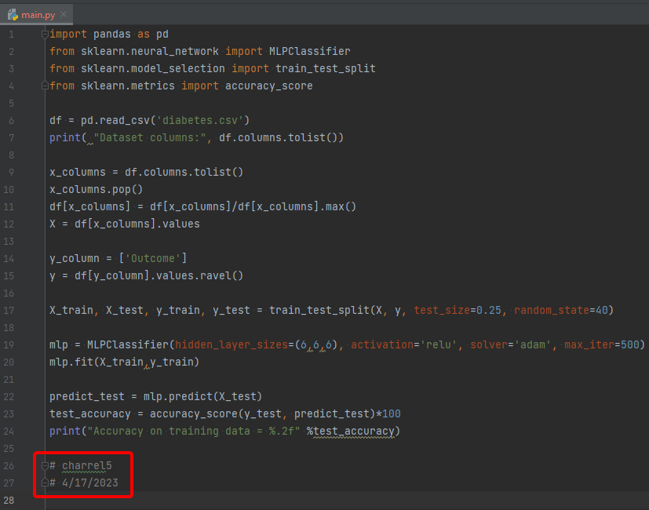

1. What is the obtained accuracy?
   1. 70.83
   2. 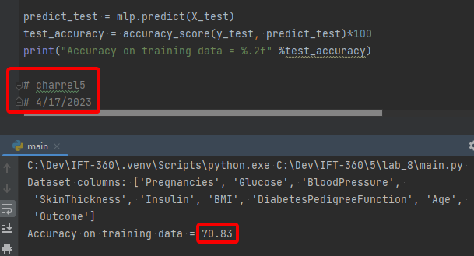
2. Try to change the number of nodes in each hidden layer from 3 to 9. Do you notice any significant changes in the obtained accuracy?
   1. No. I got identical results
   2. 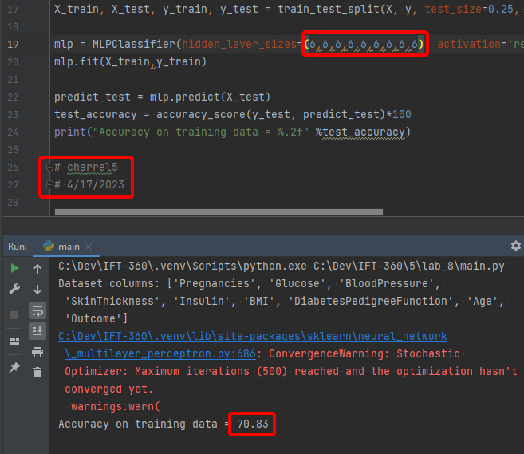
3. Show the obtained results for a number of nodes (3,4,5,6,7,8,9) in the hidden layers.
   1. 76.56
   2. 